LAB 2

Question 1

1)

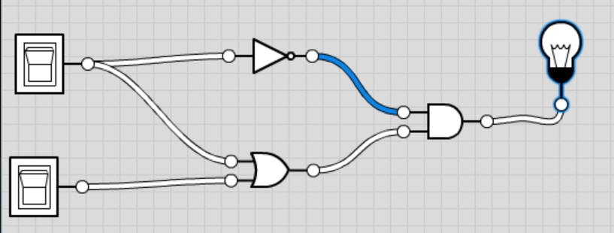

2)

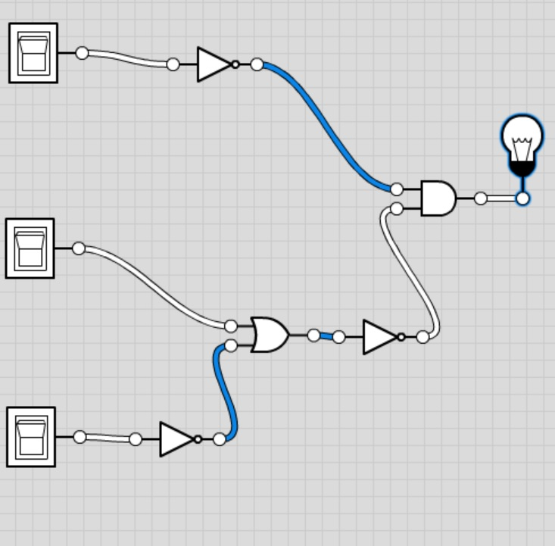

3)

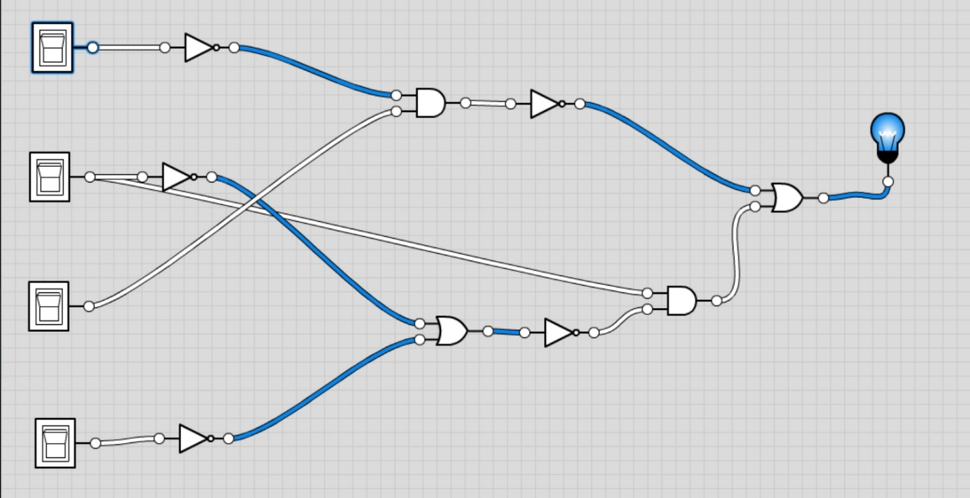

Question 2)

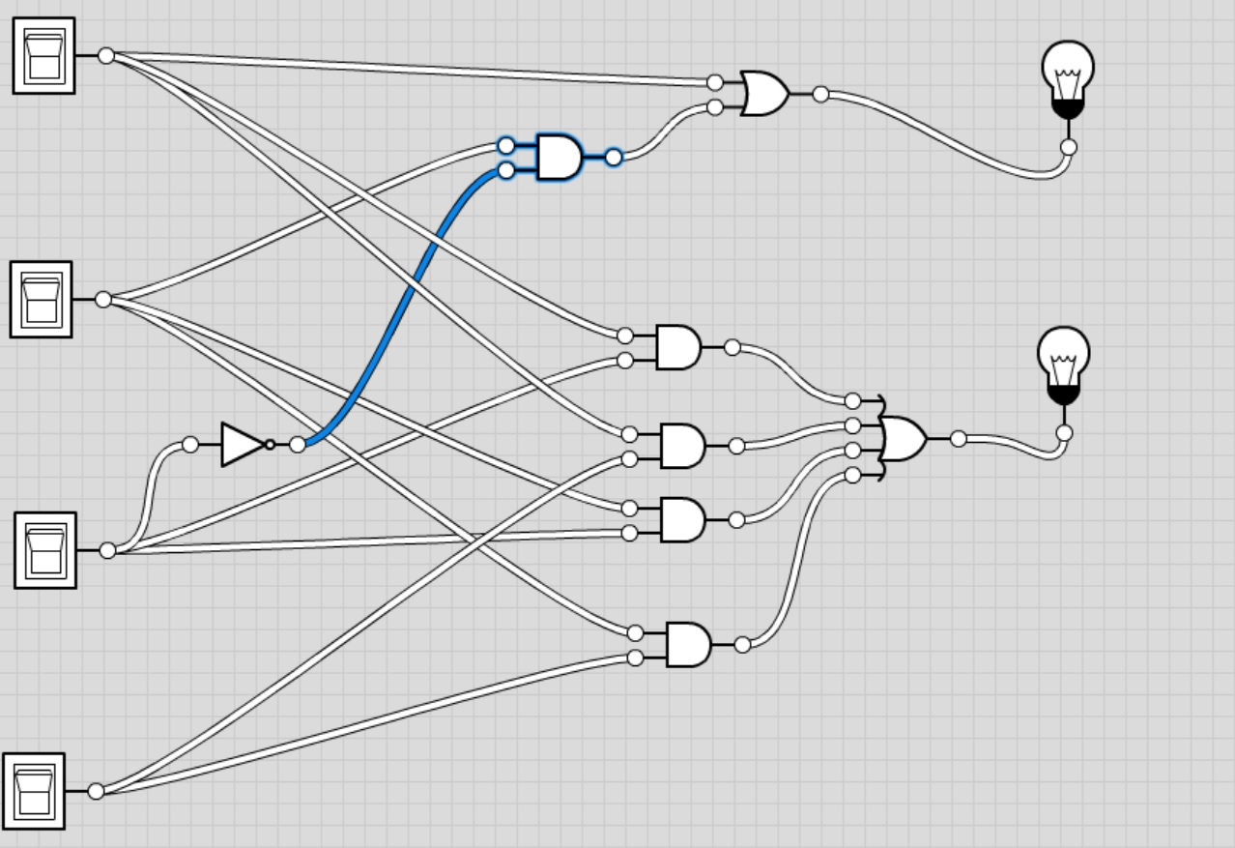

Question 3)

Equations:

A= a+b+c+d

B= (!a∙b)+c+d

C=a+b+c+d

D=a+b+(!c∙d)

X=A∙B

Y=C∙D

Truth Table:

|  |  |  |  |  |  |  |  |  |  |  |  |
| --- | --- | --- | --- | --- | --- | --- | --- | --- | --- | --- | --- |
| a | b | c | d |  | A | B | C | D |  | X | Y |
| 0 | 0 | 0 | 0 |  | 0 | 0 | 0 | 0 |  | 0 | 0 |
| 0 | 0 | 0 | 1 |  | 1 | 1 | 1 | 0 |  | 1 | 0 |
| 0 | 0 | 1 | 0 |  | 1 | 1 | 1 | 1 |  | 1 | 1 |
| 0 | 0 | 1 | 1 |  | 1 | 1 | 1 | 0 |  | 1 | 0 |
| 0 | 1 | 0 | 0 |  | 1 | 1 | 1 | 1 |  | 1 | 1 |
| 0 | 1 | 0 | 1 |  | 1 | 1 | 1 | 1 |  | 1 | 1 |
| 0 | 1 | 1 | 0 |  | 1 | 1 | 1 | 1 |  | 1 | 1 |
| 0 | 1 | 1 | 1 |  | 1 | 1 | 1 | 1 |  | 1 | 1 |
| 1 | 0 | 0 | 0 |  | 1 | 0 | 1 | 1 |  | 0 | 1 |
| 1 | 0 | 0 | 1 |  | 1 | 1 | 1 | 1 |  | 1 | 1 |
| 1 | 0 | 1 | 0 |  | 1 | 1 | 1 | 1 |  | 1 | 1 |
| 1 | 0 | 1 | 1 |  | 1 | 1 | 1 | 1 |  | 1 | 1 |
| 1 | 1 | 0 | 0 |  | 1 | 0 | 1 | 1 |  | 0 | 1 |
| 1 | 1 | 0 | 1 |  | 1 | 1 | 1 | 1 |  | 1 | 1 |
| 1 | 1 | 1 | 0 |  | 1 | 1 | 1 | 1 |  | 1 | 1 |
| 1 | 1 | 1 | 1 |  | 1 | 1 | 1 | 1 |  | 1 | 1 |

Circuit:

